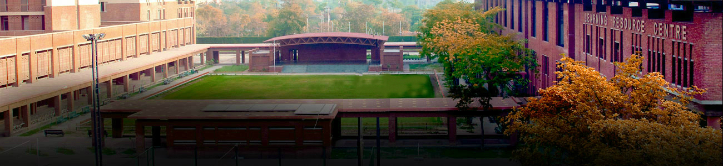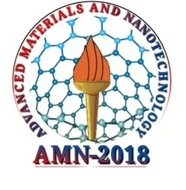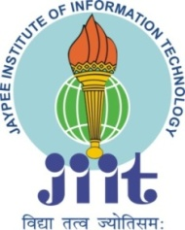

**National Conference on Advanced Materials and Nanotechnology**

**(AMN-2018)**

**15-17 March 2018**

**Organized By**

**Department of Physics and Materials Science & Engineering**

**Jaypee Institute of Information Technology Noida**

ABOUT THE ORGANIZATION

Jaypee Institute of Information Technology (JIIT) was founded in 2001 with the vision of becoming a centre of excellence in the field of IT and related emerging areas of education, training and research comparable to the best in the world for producing professionals who shall be leaders in innovation, entrepreneurship, creativity and management. JIIT has been ranked 54th in the all India rank 2017 in engineering category by NIRF, Ministry of HRD, Government of India.

Department of Physics and Materials Science & Engineering (PMSE) has not only played a key role in supporting the undergraduate and post graduate education for all disciplines in JIIT but also attracted worldwide attention by carrying out exceptional research in the fields of Advanced Materials, Nano Materials, Optics, Plasma Physics, and Quantum Information Theory. The Department of PMSE has been running M.Tech. Programme in Materials Science & Engineering and Ph.D. Programme under the 22 expert faculty members who are actively engaged in cutting edge research in the frontier areas of engineering science and nanotechnology. In the last 5 years, more than 200 papers have been published by the department in the journals of international repute.

**AMN-2018**

**National Conference on Advanced Materials and Nanotechnology (AMN- 2018)** aims to bring together leading academician, scientists, and researchers to exchange and share their thoughts, experiences and research outcome on all aspects of functional/engineering materials and their applications in nanotechnology and devices. It provides an interdisciplinary platform for researchers to present and discuss their most recent findings, innovations and experimental/practical challenges encountered in solving the problems in the fields of developing new materials and their applications.

REGISTRATION FEE & IMPORTANT DATES

BROAD AREAS TO BE COVERED

* Functional Materials/Spintronics/ Multiferroics
* Optical/Optoelectronic Materials/ Chalcogenides
* Ferroelectrics/Piezoelectrics/MEMS/Soft Materials
* Glasses and Amorphous Systems
* Magnetic Materials/Ferrites/Superconductors
* Nano-materials/Nanotechnology/Surfaces, Interfaces, Thin Films
* Gas Sensors /Bio Sensors
* Energy Materials/Fuel Cells/Batteries/Super capacitors
* Solar Cells/DSSC/Semiconductor Physics and Devices
* Materials Engineering/Materials Synthesis and Properties
* Theoretical and Computational Materials Science

NATIONAL ADVISORY COMMITTEE

|  |  |
| --- | --- |
| * Prof. S. K. Joshi, Former Director General, CSIR | * Prof. S. M. Shivaprasad, JNCASR, Bangalore |
| * Dr. D. K. Aswal, Director NPL | * Prof. Om Parkash, IITBHU |
| * Prof. Sushil Auluck, IITR | * Prof. Sanjay Puri, JNU |
| * Prof. S. B. Ogale, IISER Pune | * Prof. D. Pandey, IITBHU |
| * Prof. A. K. Tyagi, BARC, Mumbai | * Prof. A. K. Nigam, TIFR |
| * Prof. D. Bahadur, IITB | * Prof. K. L. Yadav, IITR |
| * Prof. V. D. Vanker, IITD | * Prof. Vinay Gupta, DU |
| * Prof. Zakir Hossain, IITK | * Prof. D. Kumar, IITBHU |
| * Prof. M. Husain, JMI, Delhi | * Prof. P. Alagarsamy, IITG |
| * Prof. B. R. Mehta, IITD | * Dr. Chandra Prakash, DRDO |
| * Dr. Rajeev Ranjan , IISc, Bangalore | * Prof. S. A. Hashmi, DU * Dr. Amitava Roy, DST |

ORGANIZING COMMITTEE

|  |  |
| --- | --- |
| Student participants | Rs. 2500/- |
| Academicians/Scientists | Rs. 3500/- |
| Accompanying Person | Rs. 1000/- |
| Accommodation | *Rs. 1000/- (per night per person)  **#**Rs. 500/- (per night per person) |
| Conference Date | March 15 -17, 2018 |
| Submission of paper open | September 20, 2017 |
| Submission closed | December 15, 2017 |
| Notification of Acceptance | January 10, 2018 |
| Registration up to | January 31, 2018 |

Registration fee includes registration kit, tea and lunch during conference.

**\***Limited guest house accommodation (twin sharing) with breakfast & dinner.

**#**Hostel accommodation (twin sharing) with breakfast & dinner.

**Selected peer reviewed papers of the participants will be published in AIP conference proceeding without any extra charge.**

Chief Patron: Sh. Jai Prakash Gaur, Founder Chairman,

Jaypee Group

Sh. Manoj Gaur, Executive Chairman,

Jaypee Group

Patron: Prof. S. C. Saxena, Vice Chancellor

Convener: Prof. R. K. Dwivedi

Email: [rk.dwivedi@jiit.ac.in](mailto:rk.dwivedi@jiit.ac.in)

Co-conveners: Dr. Navendu Goswami

Email: [navendu.goswami@jiit.ac.in](mailto:navendu.goswami@jiit.ac.in)

Dr. Manoj Kumar

Email: [manoj.chauhan@jiit.ac.in](mailto:manoj.chauhan@jiit.ac.in)

Organizing Secretary: Dr. Himanshu Pandey

Email: [himanshu.pandey@jiit.ac.in](mailto:himanshu.pandey@jiit.ac.in)

**Communication Details:**

Registration and Accommodation:

Dr. Manoj Kumar, Ph. 0120-2594360, [amn2018register@gmail.com](mailto:amn2018.register@gmail.com)

Paper submission and Publication:

Dr. Navendu Goswami, Ph. 0120-2594364, [amn2018paper@gmail.com](mailto:amn2018paper@gmail.com)

**Websites:** [**www.amn2018.com**](http://www.amn2018.com)**,** [**www.jiit.ac.in**](http://www.jiit.ac.in)

**Department of Physics and Materials Science & Engineering, Jaypee Institute of Information Technology, A-10, Sector-62, Noida-201309, U.P. India**